Practicum No.8 Date:……….
DMA Simulation

- Practical Significance

This practicum helps students understand how data can move quickly between memory and devices without slowing down the CPU. It shows the importance of DMA in real systems where large files, videos, or sensor data must be transferred efficiently. By simulating DMA, students can see how the CPU stays free for other tasks while the transfer continues in the background. This knowledge connects classroom concepts to real-world uses like gaming, streaming, and embedded systems where speed and multitasking are critical.

- Competency and Industry-Specific Practical Skills

This practicum exercise is expected to develop the following skills for the industry-identified competency.
- Evaluate the performance of scalable architectures for intelligent systems to ensure reliability.
(As stated in the Course Structure)
- Implement cache mapping techniques and simulate direct memory access operations. (PDO)

- Relevant CO(s) (As stated in the Course Structure)

- CO3. Interpret memory functions and techniques influencing performance.

- Practical Outcome (PrO) (As stated in the Course Structure)

- Simulate DMA operations for the given memory setup using MATLAB

- Related ADO(s) (As stated in the Course Structure)

- Follow industry standards for system evaluation and performance optimization.
- Function effectively in teams to develop processor and memory architectures.
- Function responsibly in leadership roles to design computing systems.

- Minimum Underpinning Theory (Include relevant content & images for this practicum.)

Direct Memory Access (DMA) is a technique in computer systems that allows data to be transferred directly between an input/output (I/O) device and the main memory without continuous involvement of the Central Processing Unit (CPU). Normally, the CPU manages all data movement, which can slow down processing, but with a DMA controller, data transfers are handled independently, allowing the CPU to focus on other operations.

This improves system efficiency and throughput, especially in applications where large amounts of data must be moved quickly, such as multimedia, disk operations, or real-time communication. By bypassing the CPU and reducing bottlenecks, DMA ensures faster and smoother performance, making it a vital concept in modern computer architecture.

- Algorithm (Include probable photos of experimental set-up.)

- Start the program.
- Initialize memory as an array (example: memory = zeros(1,20) to store data).
- Initialize I/O device data (example: deviceData = randi([1 99],1,5)).
- Display CPU idle message (to show CPU is not moving data).
- Transfer data directly from deviceData to specific locations in memory using DMA logic (example: memory(1:5) = deviceData).
- Print updated memory contents to show DMA transfer.
- Print CPU free message (to indicate CPU was bypassed).
- End the program.

- Resources Required

S. No. | Resource | Suggested Broad Specification | Quantity
1 | Laptop | Intel Core i5/i7 processor, 8GB RAM, Windows OS recommended for 8086 emulator | 1 No.
2 | MATLAB | https://matlab.mathworks.com/ | 1 No.

- Safety Precautions

- Do not run unfamiliar or unverified scripts found online which may harm your computer.
- Verify your register usage and memory addresses to avoid system-level crashes or infinite loops.
- Close all other programs before executing large or unknown assembly code to free up resources.
- Use licensed version of MATLAB to avoid security or legal issues.

- Procedure (Self-Instructional)

1. Switch on the computer.
2. Open MATLAB on your computer.
3. Create a new script file (File → New → Script).
4. Run the following MATLAB script and note the values on the console.
% Practicum: Illustrate DMA Operations
clc; clear;

% Step 1: Initialize memory (20 locations, all zero)
memory = zeros(1,20);

% Step 2: Generate random data from I/O device (5 values)
deviceData = randi([1 99],1,5);

disp('Initial Memory:');
disp(memory);

% Step 3: Show CPU is free (not moving data)
disp('CPU is free. DMA will handle data transfer...');

% Step 4: DMA transfers data directly into memory (locations 1 to 5)
memory(1:5) = deviceData;

% Step 5: Display updated memory contents
disp('Updated Memory after DMA Transfer:');
disp(memory);

% Step 6: Show data received from I/O device
disp('Data received from device:');
disp(deviceData);

% Step 7: Indicate completion
disp('DMA transfer completed without CPU involvement.');
5. Shutdown the computer

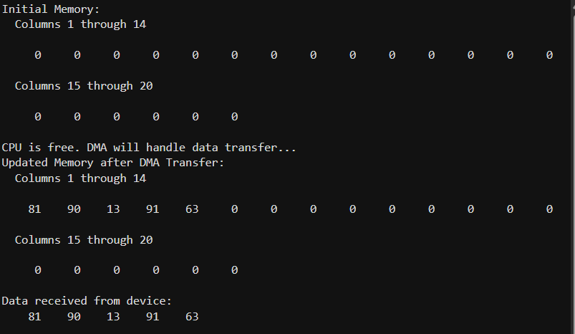
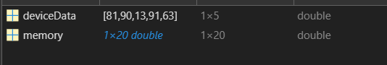

ADDITION QUESTION:

1. Evaluate how DMA improves system performance compared to CPU-controlled data transfer.

CODE:
clc; clear;
close all;

dataSize = 1000000;
data = rand(1, dataSize);
tic

memory_cpu = zeros(1, dataSize);
for i = 1:dataSize
memory_cpu(i) = data(i);
end
cpu_time = toc;

tic
memory_dma = data;
dma_time = toc;

fprintf('CPU Controlled Transfer Time: %f seconds\n', cpu_time);
fprintf('DMA Transfer Time: %f seconds\n', dma_time);

if dma_time < cpu_time
disp('DMA transfer is faster and improves system performance.');
else
disp('CPU transfer took similar or less time.');

end
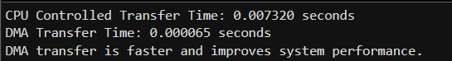
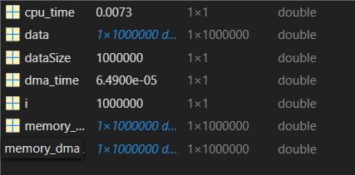

2. Demonstrate how bypassing the CPU during data transfer saves time and power.

CODE:
clc; clear;
close all;

dataSize = 500000;

data = rand(1,dataSize);

cpuMemory = zeros(1,dataSize);
tic

for i = 1:dataSize
cpuMemory(i) = data(i);
end

cpuTime = toc;

tic
dmaMemory = data;
dmaTime = toc;

cpuPower = cpuTime * 50;
dmaPower = dmaTime * 50;

fprintf('CPU Controlled Transfer Time: %f seconds\n', cpuTime);
fprintf('DMA Transfer Time: %f seconds\n', dmaTime);
fprintf('Estimated CPU Power Consumption: %f units\n', cpuPower);
fprintf('Estimated DMA Power Consumption: %f units\n', dmaPower);

if dmaTime < cpuTime
disp('Bypassing CPU using DMA saves time.');
end

if dmaPower < cpuPower
disp('DMA also reduces power consumption.');

end

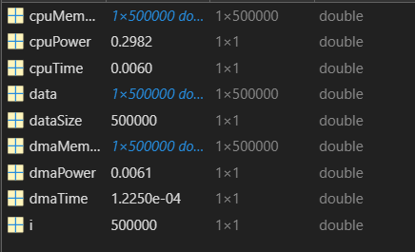
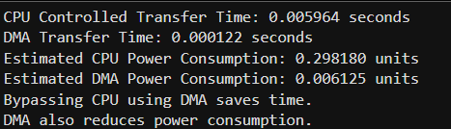

- Actual Resources Used (To be filled by the students)

S. No. | Name of Resource | Broad Specifications |  | Data | Remarks  (If any)
 |  | Tool | Version
 | Laptop | Intel Core i5 Processor, 8GB RAM | MATLAB | R2023a | Used for simulation
 | MATLAB Software | Numerical computing and simulation software | MATLAB | R2023a | Used to run DMA program
 | Internet | Broadband connection | Chrome | Latest | Used for reference
 | Operating System | Windows OS | Windows | Windows 11 | System environment

- Actual Procedure Followed

- The computer system was switched on and MATLAB software was opened.
- The provided MATLAB program for DMA simulation was typed in the script editor.
- Memory was initialized as an array with 20 locations using memory = zeros(1,20).
- Random data from the I/O device was generated using deviceData = randi([1 99],1,5).
- The CPU idle message was displayed to indicate that the CPU is not involved in data transfer.
- The DMA controller transferred the device data directly to memory locations 1 to 5.

- Observations and Dimensional Measurement

S. No. | Observations | Data | Remarks
1 | Memory Size | 20 locations | Initialized using zeros
2 | Device Data Size | 5 values | Generated randomly
3 | Data Transfer Method | Direct Memory Access | CPU not involved
4 | Memory Update | First 5 locations updated | Successful DMA transfer

- Results/Observations

The MATLAB program successfully simulated the Direct Memory Access (DMA) operation. Data generated from the I/O device was transferred directly into memory locations without CPU intervention. The updated memory array confirmed that the DMA controller handled the data transfer efficiently.

- Interpretation of Results

The results show that DMA allows data transfer directly between an I/O device and memory without continuous CPU involvement. This improves system performance because the CPU remains free to perform other tasks while the DMA controller handles the data transfer. This technique is widely used in systems that require fast and efficient data movement.

- Conclusions

The practicum successfully demonstrated the working principle of Direct Memory Access using MATLAB simulation. The experiment showed how DMA transfers data directly from an I/O device to memory while keeping the CPU free for other processes. This technique significantly improves system efficiency and is commonly used in modern computing systems.

- Suggested Practicum Related Questions:

Note: Below are a few questions related to industry-specific higher-order thinking skills (HOT) that teachers must use to ensure students achieve the predetermined course outcomes.

- Explain why industries prefer DMA instead of letting the CPU handle all data transfers.
- Illustrate how DMA makes multitasking (like browsing while playing music) possible.
- Predict what could happen if DMA was not used in a high-speed device like a hard disk.
- Evaluate how DMA improves system performance compared to CPU-controlled data transfer.
- Assess why DMA is important in real-time systems like robotics or medical devices.
- Demonstrate how bypassing the CPU during data transfer saves time and power.
- Examine the role of a DMA controller in efficient memory management.
- Discuss how frequent CPU involvement in data transfer might affect online gaming.
- Justify why DMA is critical for large file transfers in industries like video editing or banking.
- Propose how understanding DMA can help engineers design faster computer systems.

- References / Suggestions for further reading

- I/O Interface (Interrupt and DMA Mode) - https://www.geeksforgeeks.org/computer-organization-architecture/io-interface-interrupt-dma-mode/
- Interrupts and DMA - https://youtu.be/2W5igWi1I-8

- Suggested Assessment Scheme

The performance indicators given serve as a guideline for assessing the ‘process-related skills/LOs’ (marks to be awarded in real-time in the laboratory by the faculty member, as these cannot be measured after the practicum is over) and ‘product-related skills/LOs’

Note: The weightage for the process-related skills and product-related skills will change depending on the PrO, COs, and the competency related to the concerned course.

Performance Indicators |  | Maximum Marks | Marks Obtained
Process-related Skills: 18 Marks - 60%
1 | Follow industry standards | 3
2 | Function effectively in teams | 2
3 | Function responsibly in leadership | 3
4 | Implement cache mapping techniques and simulate direct memory access operations | 10
Product-related Skills: 12 Marks - 40%
5 | Uses correct commands or syntax in Tool | 3
6 | Results | 3
7 | Interpretation of Results | 3
8 | Conclusion | 3
Total |  | 30

To be filled by Student:

S.No. | Name of the Student | Register No.
1 | NEAVIS RISHVA. J | URK25CS1236

To be filled by the Faculty Member:
Marks Obtained |  |  | Name and Designation of the Faculty Member | Date of Evaluation
Process-Related Skills  (18) | Product-Related Skills (12) | Total  (30)

*******

